**Due Date: March 1st, 2021 11:59pm**

**Program-1[40 points]: Nested loops**

Write an ARM assembly code to produce the same output given below. You are supposed to use nested loops in your assembly code. Please name your file as nestedfor.s.

**Sample Run:**

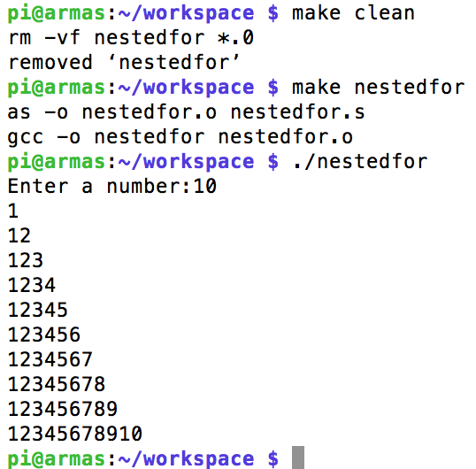

**Program-2[60 points]: Guess Number Game**

Write an ARM Assembly program to get the user to guess the number that the program has randomly picked. Please name your file as game.s.

**Sample run:**

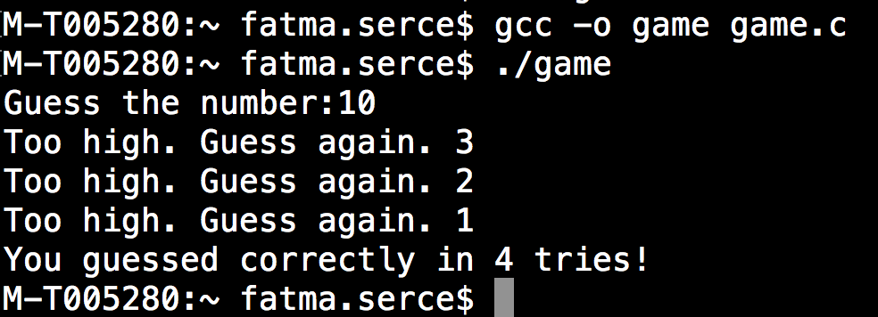

**Hint:** The following C program, random.c, is given as an example for generating a random number.

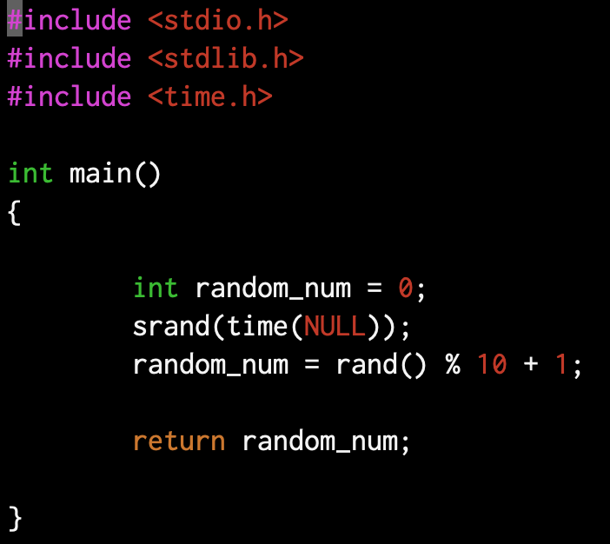

The following figure also shows how to compile and execute a C program.

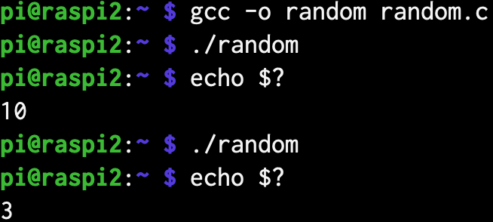

**How to submit**

Please submit your work as a single zip file including the following files

* nestedfor.s
* game.s

Please also use the following file format while naming the zip file:

LastNameFirstnameX_Y.zip where LastNameFirstname is your last name with the first letter in capital, followed by your first name with the first letter in capital; the X is the course code; the Y is the assignment #. (ex: SerceFatmaCS351_3.zip)

**How to Evaluate:**

*nestedfor.s (40 points)*

* works without error
* use nested loops properly
* documented and formatted

*game.s (60 points)*

* works without error
* uses stacks properly
* uses functions properly
* documented and formatted